**DAY 5**

1)

Do the below programs in anonymous function & IIFE

1. --Print odd numbers in an array

**ANSWER**

**ANANYMOUS FUNCTION**

let odd_numbers = function(arr)

{

for(let i in arr)

{

if(arr[i]%2!=0) //IF ELEMENT %2!=0 ITS ODD

console.log(arr[i]);

}

}

let arr = [1,2,3,4,5]

odd_numbers(arr);

**IIFE**

(function(arr){

for(let i in arr)

{

if(arr[i]%2!=0)

console.log(arr[i]);

}

})([1,2,3,4,5,6]);

**OUTPUT**

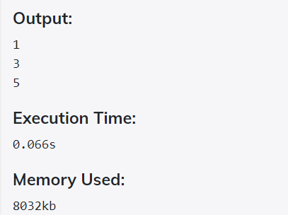

1. --Convert all the strings to title caps in a string array

**ANSWER**

**ANANYMOUS**

let title_caps = function(arr)

{

for(let i in arr)

{

console.log(arr[i].charAt(0).toUpperCase() + arr[i].slice(1));

}

}

let arr = ["abc","def","ghi","jkl"]

title_caps(arr);

IIFE

(function(arr){

for(let i in arr)

{

console.log(arr[i].charAt(0).toUpperCase() + arr[i].slice(1));

}

})(["abc","def","ghi","jkl"]);

**OUTPUT**

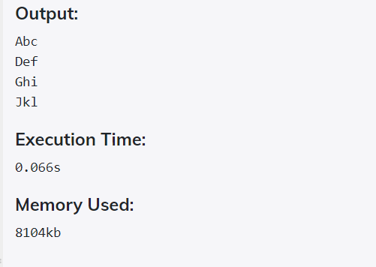

1. --Sum of all numbers in an array

**ANSWER**

**ANANYMOUS**

let array_sum = function(arr)

{

let sum=0;

for(let i in arr) //GET EACH ELEMENT OF ARRAY IN VARIABLE I

{

sum += arr[i]; //ADD EACH VALUES

}

console.log(sum);

}

let arr = [1,2,3,4,5]

array_sum(arr);

IIFE

(function(arr){

let sum=0;

for(let i in arr)

{

sum += arr[i];

}

console.log(sum);

})([1,2,3,4,5]);

**OUTPUT**

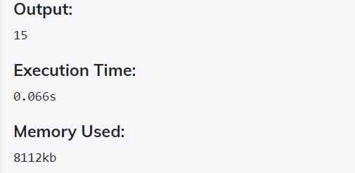

1. --Return all the prime numbers in an array

**ANSWER**

**ANANYMOUS**

let prime_numbers = function(arr)

{

arr = arr.filter((number) => {//FILTER VALUES

for (var i = 2; i <= Math.sqrt(number); i++) {

if (number % i === 0) return false;

}

return true;

});

console.log(arr);

}

let arr = [1,2,3,4,5]

prime_numbers(arr);

IIFE

(function(arr){

arr = arr.filter((number) => {

for (var i = 2; i <= Math.sqrt(number); i++) {

if (number % i === 0) return false;

}

return true;

});

console.log(arr);

})([1,2,3,4,5]);

**OUTPUT**

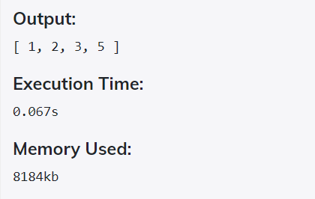

1. --Return all the palindromes in an array

**ANSWER**

**ANANYMOUS**

let palindromes = function(arr)

{

for(let x in arr)

{

let string1 = arr[x];//STORE THE FIRST ELEMENT

let string2 = arr[x].split("").reverse().join("");//REVERSE AND JOIN THE REMAINING

if(string1 == string2)

console.log(arr[x]);

}

}

let arr = ["121","432","242"];

palindromes(arr);

IIFE

(function(arr){

for(let x in arr)

{

let string1 = arr[x];

let string2 = arr[x].split("").reverse().join("");

if(string1 == string2)

console.log(arr[x]);

}

})(["121","432","242"]);

**OUTPUT**

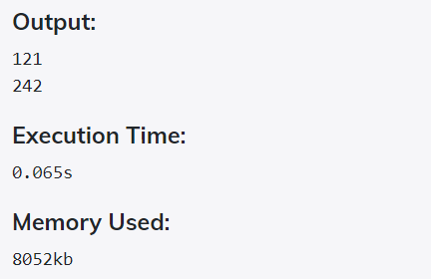

1. --Return median of two sorted arrays of same size

**ANSWER**

**IIFE**

(function (arr1,arr2)

{

let m1=0;

let m2=0;

if(arr1.length%2==0 || arr2.length%2==0)

{

m1=(arr1[Math.floor(arr1.length/2)]+arr1[Math.floor(arr1.length/2)-1])/2;

m2=(arr2[Math.floor(arr2.length/2)]+arr2[Math.floor(arr2.length/2)-1])/2;

}

else

{

m1=(arr1[Math.floor(arr1.length/2)]);

m2=(arr2[Math.floor(arr2.length/2)]);

}

let sol=(m1+m2)/2;

console.log("Median : "+sol);

})([1,2,3,4,5],[21,22,23,24,25]);

ANANYMOUS

let median = function (arr1,arr2)

{

let m1=0;

let m2=0;

if(arr1.length%2==0 || arr2.length%2==0)

{

m1=(arr1[Math.floor(arr1.length/2)]+arr1[Math.floor(arr1.length/2)-1])/2;

m2=(arr2[Math.floor(arr2.length/2)]+arr2[Math.floor(arr2.length/2)-1])/2;

}

else

{

m1=(arr1[Math.floor(arr1.length/2)]);

m2=(arr2[Math.floor(arr2.length/2)]);

}

let sol=(m1+m2)/2;

console.log("Median : "+sol);

};

median([1,2,3,4,5],[21,22,23,24,25]);

**OUTPUT**

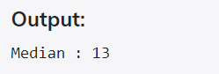

1. --Remove duplicates from an array

**ANSWER**

**ANONYMOUS**

let duplicates = function (arr)

{

let sol=new Array()

for(let i=0;i<arr.length;i++)

{

if(sol.includes(arr[i]))

{

continue;

}

else

{

sol.push(arr[i])

}

}

console.log("dUP:");

console.log(sol);

}

duplicates([1,3,2,4,3,2,4,4,4]);

**OUTPUT**

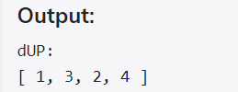

1. -- Rotate an array by k times

**ANSWER**

let rotate = function (arr,k)

{

let val=k%arr.length;

let sol=new Array(arr.length);

let j=0;

for(let i=val;i<arr.length;i++)

{

sol[j++]=arr[i];

}

for(let i=0;i<val;i++)

{

sol[j++]=arr[i];

}

console.log("After rotation");

console.log(sol);

}

rotate([1,2,3,4,5],8);

**OUTPUT**

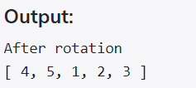

3)

Do the below programs in arrow functions

1. --Print odd numbers in an array

**ANSWER**

let odd_numbers = (arr) =>

{

for(let i in arr)

{

if(arr[i]%2!=0)

console.log(arr[i]);

}

}

let arr = [1,2,3,4,5]

odd_numbers(arr);

**OUTPUT**



1. -- Convert all the strings to title caps in a string array

**ANSWER**

let title_caps = (arr) =>

{

for(let i in arr)

{

console.log(arr[i].charAt(0).toUpperCase() + arr[i].slice(1));

}

}

let arr = ["abc","def","ghi","jkl"]

title_caps(arr);

**OUTPUT**



1. --Sum of all numbers in an array

**ANSWER**

let array_sum = (arr) =>

{

let sum=0;

for(let i in arr)

{

sum += arr[i];

}

console.log(sum);

}

let arr = [1,2,3,4,5]

array_sum(arr);

**OUTPUT**



1. --Return all the prime numbers in an array

**ANSWER**

let prime_numbers = (arr) =>

{

arr = arr.filter((number) => {

for (var i = 2; i <= Math.sqrt(number); i++) {

if (number % i === 0) return false;

}

return true;

});

console.log(arr);

}

let arr = [1,2,3,4,5]

prime_numbers(arr);

**OUTPUT**



1. --Return all the palindromes in an array

**ANSWER**

let palindromes = function(arr)

{

for(let x in arr)

{

let string1 = arr[x];

let string2 = arr[x].split("").reverse().join("");

if(string1 == string2)

console.log(arr[x]);

}

}

let arr = ["121","432","242"];

palindromes(arr);

**OUTPUT**

